pc/MRP NEWS
pc/MRP RELEASES 8.10 VERSION
Nov 2005 e-mail address: sales@pcmrp.com Internet: http://www.pcmrp.com/
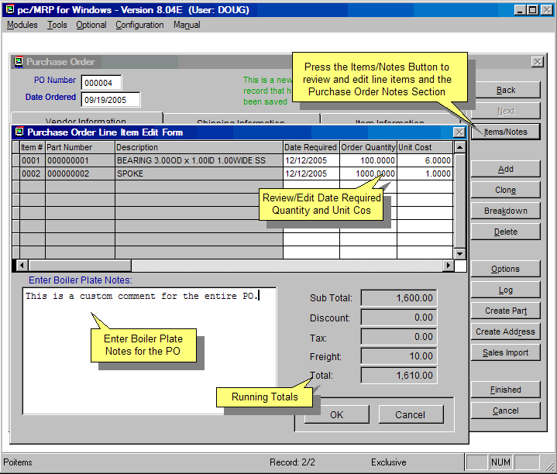

Items/Notes Button

pc/MRP’s Purchase and Sales Order Modules have a new Items/Notes Button. Clicking the button allows users to edit the Date Required, Quantity, and Unit Cost Fields. As you edit the displayed totals will reflect your changes. In addition the form’s boiler plate can be edited and saved with the form.

Larger Addresses More Stores

All addresses were expanded from 5 lines of 30 characters to 6 lines of 41 characters with larger phone and FAX numbers. The number of stores areas was increased from 6 areas to 11 areas.
Ordering Information for Update

Companies who are currently on a support contract can upgrade for free. Registered owners of pc/MRP can update to version 8.10 for $650.00. This includes 1 year of technical support (6-hour cap). To order the update, call Software Arts 408-226-7321.

Warning, if you have custom forms (Sales Order, Invoice, Checks, Purchase Order, Receiver, Shipper, Sales Quote, or Purchase Request) these files may require user modification to function properly with pc/MRP's increased address field lengths.

RoHS Compliant Support

A RoHS Compliant Checkbox has been added to pc/MRP' Inventory Module.

Improved QuickBooks Features

pc/MRP Version 8.10 has added an option to sync Quickbooks Customers and Vendors with pc/MRP in mass. In addition a QuickBooks lookup button has be added to pc/MRP's Inventory and Address Modules

Improved Stock Room Functions

pc/MRP Version 8.10 added the option to issue and receive back multiple sales order line items in one shot. In addition, pc/MRP's Convert Parts to Assemblies Option now leaves stockroom issue and receive back transaction records for improved inventory control.

Improved Excel Functionality

pc/MRP Version 8.10 added the option to select the fields you want to include in your xls file and to save the file as a template for similar reports in the future.

Improved Inspection Functionality

pc/MRP Version 8.10 added an Auxiliary Field to the Inspection Module allowing users to enter Customer PO Numbers or Vendor Invoice Numbers when performing an inspection on a part or assembly.

New Optional Tickler/Task Manager Module

pc/MRP 8.10 added an optional Task Manager/ Tickler Module allowing users to create pop up ticklers and manage various projects. See page 6 of this newsletter for a write up on this module.

Improved Accounting Functionality
pc/MRP’s Accounting Program received three major improvements. 1. Chart of accounts can have parent and sub-accounts whose totals roll into the parent accounts. For example, a Utilities Account can now contain Water, Electricity and Gas Sub Accounts. 2. An extremely strong accounting audit function was added. 3. When stepping though a month end close, debits and credit totals are displayed.
pc/MRP VERSION 8.10 NEW FEATURES
8.10A Added RoHS Compliant Checkbox to inventory data entry screen
8.10A Added tracking support for European Shipping provider TNT
8.10A Added option to automatically open PDF forms when created
8.04E Added Accounting Audit Option
8.04D Added QuickBooks Addresses Sync Option to QB Default Settings
8.04C Added Option to receive back multiple sales line items from mfg
8.04C Added Items/Notes screen to edit purchase order items and notes
8.04C Added QuickBooks Vendor/Cust Lookup Button to Address Module
8.04A Added the option to issue multiple sales order line items to mfg
8.04A Increased the size of the address fields, fax and phone numbers 8.03A Added Item/Notes screen to edit sales orders items and notes
8.02E Added the option to transfer assemblies as parts between areas
8.02D Added option to substitute one part for another in one or more BOMs
8.02D Added Utility 87 to close/open invoices and receivers in mass
8.02D Added the option save xls templates when exporting to xls files
8.02C Added the option to pick fields when exporting to xls files
8.02A Added a link to an alternate currency conversion website
8.02A Add an Aux1 field to Inspection Module for cust inv# or vendor PO#
8.01B Convert parts to assemblies creates stock transaction records
8.01B Added the option to print out stockroom adjusting transactions only
8.01A Increment document numbers will now increment alpha characters 8.01A Added Optional Tickler/Task Manager Module
8.01A Edit PO now automatically updates the onorder field in inventory
8.01A Added the ability to create chart of accounts sub-accounts
8.01A Improved Step Through Close Month Screens
8.01A Added option to display print check dialog during check run
8.01A Faster Inventory Movement Report Generation
8.01A Added the ability to select dBase III or VFP when printing to dbf

pc/MRP Optional QuickBooks Interface Module $325.00

pc/MRP’s QuickBooks Interface module exports all open invoice and receivers to QuickBooks. It posts the initial AP and AR entries into QuickBooks and eliminates double entry for those companies using QuickBooks as their accounting module.
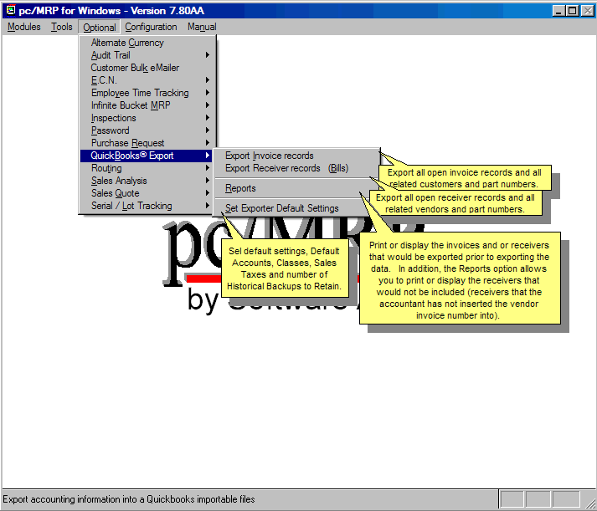
- QuickBooks (US) 2003 and above
- Uses API Interface not IIF files
- Backs up QBW file before export
- Supports Sub Accounts
- Supports Sub Classes
- Supports Credit Limits
- Supports Lockout Dates
- Debits COGS, Credits Inventory
- Supports labor in BOMs
- Single and multiple tax vendors
- Supports Sub Items

pc/MRP Optional Advanced Password Module $250.00

pc/MRP’s Advanced Password Module allows an unlimited number of user name and password combinations to control access rights (No Access, View Only, Enter and Edit, Delete, Enter, and Edit) to each pc/MRP Module.
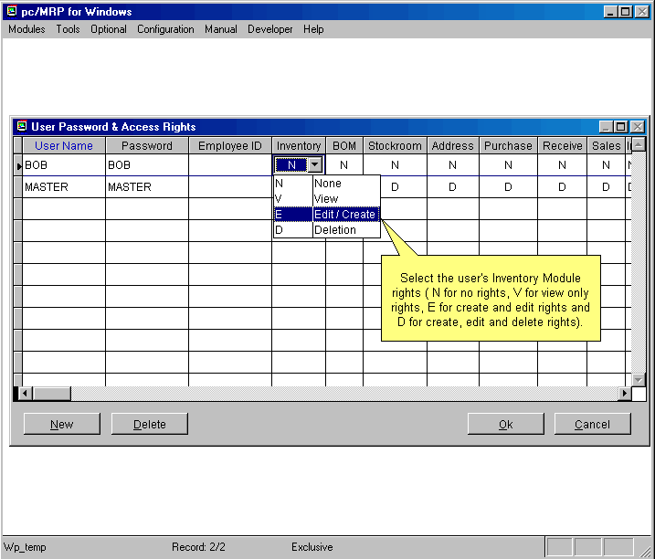
- Users can change their passwords
- Only users with Delete Rights to the Password Module can run pc/MRP’s Command Line Function.
- Users must have Delete Rights to a module to re-index that module.
- Password refresh frequency can be set in days.
- Changes to the Password module now take effect upon pressing the ‘OK’ button.

pc/MRP Optional Routing Module $250.00

pc/MRP’s Routing Module allows users to track the location of sales/work orders on the manufacturing floor. pc/MRP’s Routing Module supports the following advanced features:
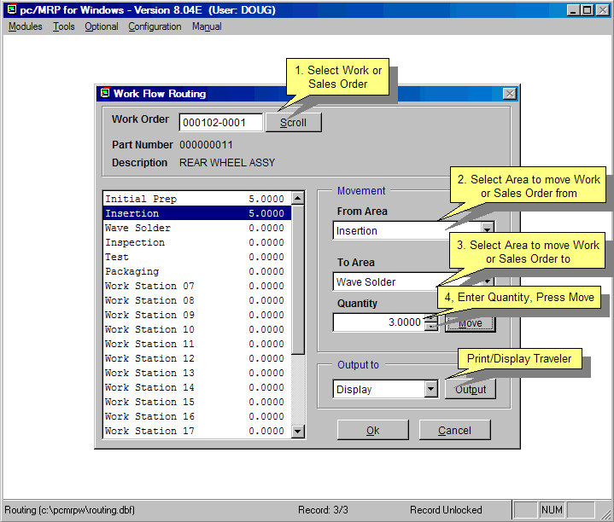
- Up to 25 user definable work areas.
- Issuing parts to manufacturing for a sales/work order automatically creates a routing record.
- Moving product into the finished goods area can automatically increments the onhand quantity of finished goods and decrements WIP quantities

pc/MRP Optional Employee/Time Sheet Module $250.00

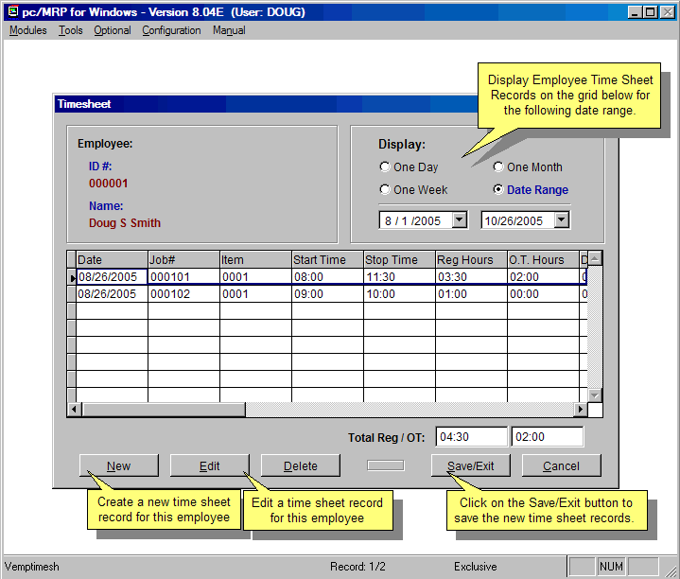
pc/MRP’s Employee/Time Sheet Module allows companies to track the actual labor cost of sales and work orders. pc/MRP’s Employee/Time Sheet Module supports the following advanced features:
- Accounting can create and manage employee records for pay rates, date hired, vacation hours, sick hours, state, and federal withholding $ amounts.
- Accounting and or individuals can create and manage employee time sheets.
- Accounting can print out actual labor hours and costs for a sales/work order from the time sheet report module.
- Accounting department can print out reports of employee’s data to enter into a payroll system.

pc/MRP Optional Infinite Bucket MRP Module $325.00

pc/MRP’s Infinite Bucket MRP Module allows users to generate MRP Action Items (PO, Buy, Issue, Make, Sale) and generate MRP Reports. Advanced features include:
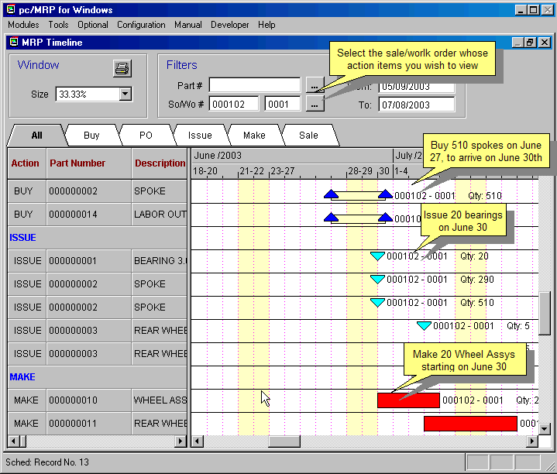
- Push Pull Reports
- Sales Quotes with probabilities
- Visual Time Line Reports
- Consumable Work Orders
- Dedicated Work Orders
- Auto PO Creation Option
- PO/Buy reports by Buyer
- Machine/Labor hours
- Visual Purchasing Graphs
- Recommends best vendor
- Consolidated reports
- Daily
- Weekly
- Monthly
- quarterly

pc/MRP Optional Inspection Module $250.00

pc/MRP's Inspection Module allows users to create global inspection requirement by:
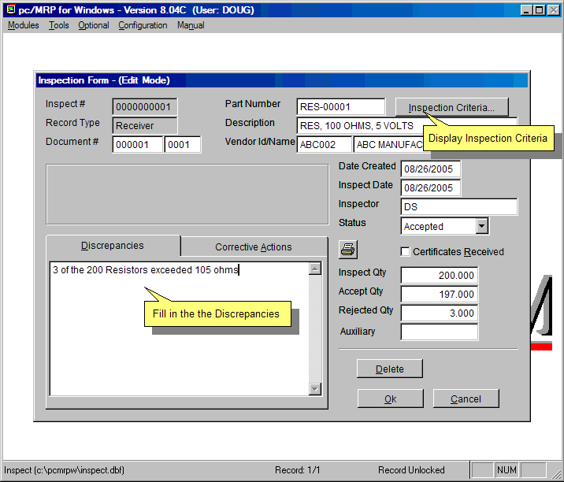
- Editing a part or assembly
- Clicking on the Inspection Criteria button
- Specifying when an inspection record will be created and displayed (received, manufactured, invoiced or shipped)
- Specifying what criteria will be used to inspect it.
- View, edit and print inspection records
- Print and or display inspection reports

pc/MRP Optional Task Manager Module $250.00

pc/MRP’s Task Manager Module allows users to enter pop up tickler messages and manage tasks to their completion. pc/MRP’s Task Manager Module supports the following advanced features:
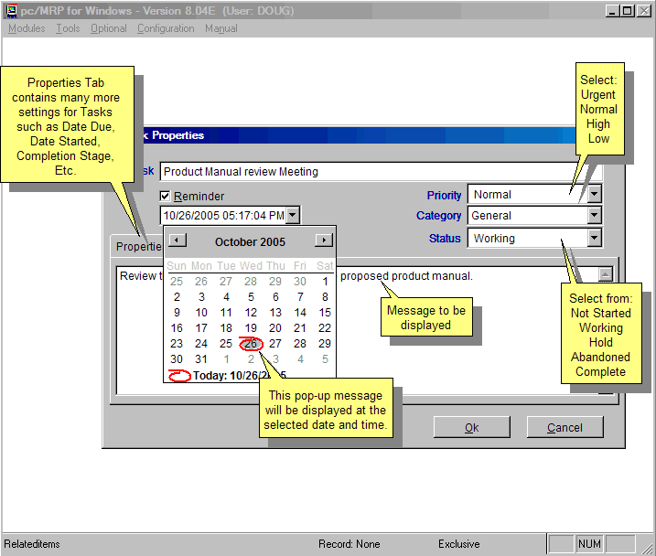
- Quickly set popup reminders
- Manage tasks and assign projects
- Task Report Options include:
- Daily
- Weekly
- Monthly
- quarterly

pc/MRP Sales
Software Arts, Inc.
6830 Via Del Oro, Suite 109
San Jose CA 95119-1353
Phone: 408-226-7321
Fax: 408-226-8435
Website: www.pcmrp.com
e-mail: sales@prmcp.com

